Journal of Sedimentary Petrology, Vol. 33, No. 4, pp. 931-937
Figs. 1-5, December, 1963
KAPTEYN’S TRANSFORMATION OF GRAIN SIZE DISTRIBUTION
――――――――――
JIŘÍ BŘEZINA
Geological Survey, Prague, Czechoslovakia
――――――――――
ABSTRACT
A method proposed by Kapteyn (1903, 1916) and Kapteyn and van Uven (1916) enables one to transform into normal distributions not only the lognormal type, which is realized in grain size distribution, as for example, by means of the phi transformation, but also, if a proper transforming
function is known, any other type of distribution. In the present paper, Kapteyn's transformation is
carried out graphically ― by means of a proposed log hydrodynamic probability chart which utilizes logarithms of settling velocity. The resulting distributions are characterized, depending upon mean
grain size and sorting, by a definite negative phi skewness; from this it is concluded that some occur
rences of the negative phi skewness result from hydrodynamic processes, and not from the mixing of certain modes or from winnowing as described by Folk and Ward (1957), Folk (1961, p. 5-6) and Friedman (1961). The ideal log hydrodynamic probability chart would remove from the grain size distribution curves the negative phi skewness and other hydrodynamically caused features common
to all sediments deposited by water. Deviations of the transformed distributions could then be inter
preted in terms of effects of local geologic or hydrodynamic environments. Existing grain size dis
tribution measures are not effective in dealing with all types of grain size distributions.
――――――――――

introduction

Kapteyn (1903) derived the lognormal distribution as a special case of transformed normal distributions. The objections of
Pearson (1905; 1906) concerning the super-
fluity of such a transformation, turned out
not to be well-founded (Aitchison and
Brown, 1957, p. 21-22). During the em
pirical stage of research, ignorance of the
real reasons for use of the normalizing func
tion is, generally speaking, only temporary.
Search for such causes will be a matter of
further research, based on careful analysis of physical and other factors acting in the given random process.
In grain size distributions, logarithmic transformation began to be used rather instinctively (Hatch and Choate, 1929),
namely when geometric scales (Sparre, 1858,
1869; Rittinger, 1863; Udden, 1898; Hop
kins, 1899; Atterberg, 1905), and especially logarithmic scales (Weinig, 1933; Krumbein, 1934, 1937; Baturin, 1943) were introduced.
The genesis of lognormal grain size distribu
tion was explained first by the theory of
breakage (Kolmogoroff, 1941; Epstein, 1947; Kottler, 1950; Tschernyj, 1950; Stange,
1953; Gebelein, 1956; Filipoff, 1961); this explanation, however, is not sufficient for sediments. The hydrodynamic scale of Robinson (1924), based on settling velocity
- Manuscript received August 13, 1962.

logarithms, may be taken as the first approach to a hydro dynamical theory.
The present paper deals with grain size distributions generated by Kapteyn’s transformation, if the normalizing function is the settling velocity logarithm as a function of grain diameter. Thus, grain size populations not exceeding the range of Stokes or Newton ( = impact) sedimentation laws may follow the lognormal distributions.
log hydrodynamic probability chart *)
The logarithm of the settling velocity (experimental data of Sarkisian, 1958, p. 343: approximately spherical quartz grains, water temperature 20°C) is taken as the normalizing function. The respective equation results from the general formula
v = cd^{n} (la)
(v = settling velocity in mm/sec, d = grain diameter in mm, c = constant, depending upon diameter values to a certain degree,
n = exponent, determining slope of the curve (la) in logarithmic coordinates); consequently
log v = log c + n log d . (1b)
Within the range of Stokes or Newton laws, the values of c and n are constant, and
*) It is assumed, that probability (i.e. frequency) of grain size occurrence does not directly depend on the grain size millimeter value but on the logarithm of grain settling velocity in water. jb 1963

3 JIŘÍ BŘEZINA

LOG HYDRODYNAMIC SCALE
.05.0.7 .1 .2 .3 .4.5 7 1 2 5 mm
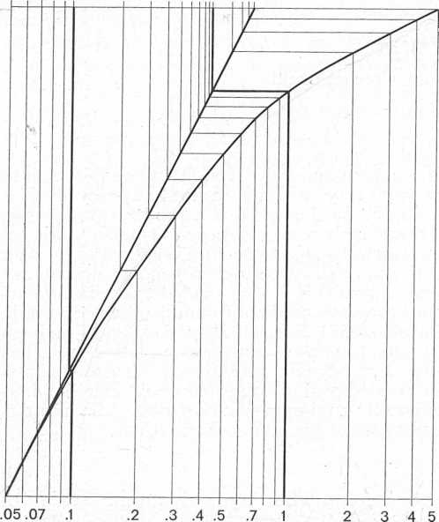
mm
LOGARITHMIC SCALE
Fig. 1. ― Construction of log hydrodynamic scale.
Ordinate: settling velocity logarithms.
therefore, the settling velocity is a simple logarithmic function of grain diameter; the logarithm of the settling velocity is a linear function of the logarithm of the grain diameter, and the logarithmic scale really corresponds to linear changes of settling velocity logarithms. Consequently, the grain size populations sorted by water in the range of Stokes or Newton laws follow lognormal distributions transformable by only logarithms into normal ones.
Within the transition range where the values of c and n change in dependence upon the values of grain diameters, the settling velocity is no more a simple logarithmic function of grain diameter, and the settling velocity logarithm is no more a linear function of grain diameter logarithm. As the theoretical settling velocity laws deviate somewhat from the observed values, and the derivation of an exact equation from experimental data would result in complicated expressions, the present paper uses an easy and sufficiently accurate graphical procedure. Figure 1 shows the construction of a proposed log hydrodynamic scale arranging grain diameter values in such a way that the changes of the settling velocity logarithms are linear. The scale is logarithmic within
the range of Stokes or Newton laws only, the range of the latter having a quarter
cycle as compared with the range of the former. This corresponds to the fact that
the value of exponent n is for Newton law one quarter of the exponent that applies for Stokes law: n_{V}= 0.5; n_{S} = 2.0.
By orthogonal combination of the log hydrodynamic scale with the probability scale, a log hydrodynamic probability chart arises in which straight lines with slopes in the range 0°-90° represent grain size distributions generated by water sorting of quartz grains, logarithms of their diameters having uniform ( = rectangular) distributions. The straight lines in figure 2 demonstrate the grain size distributions with different median values and with dispersions corresponding in the Stokes law range to Inman's phi-deviation measure 0.72.
These distributions follow Kapteyn general normalizing equation
$f=\frac{1}{σ_{z}\sqrt{2π}}e^{{−{\left(z−\bar{z}\right)}^{2}}/2σ_{z^{2}}}$ (2)
where the variate $\overline{z}$ is a function of the observed variate which linearizes the latter
and normalizes the observed distribution. In the given case, consequently, according to the eq. (lb)
z = log v = log c + n log d.
The hydrodynamic mean value z is most easily representable by the median (in millimeters, phi-values, settling velocity logarithms):
z = F_{z}⁻¹(50%),
the hydrodynamic standard deviation σ_{z} by the half difference of quantiles expressed in settling velocity logarithms.
F_{z}⁻¹(84.1%) - F _{z}⁻¹ (15.9%)
σ_{z} = ―――――――――――――――――
2
Grain size distributions defined in this way deviate from lognormality by various negative phi-skewness values, as shown by their curves plotted on a log probability chart (fig. 3). The dependence of Inman's

TRANSFORMATION OF GRAIN SIZE DISTRIBUTION 5
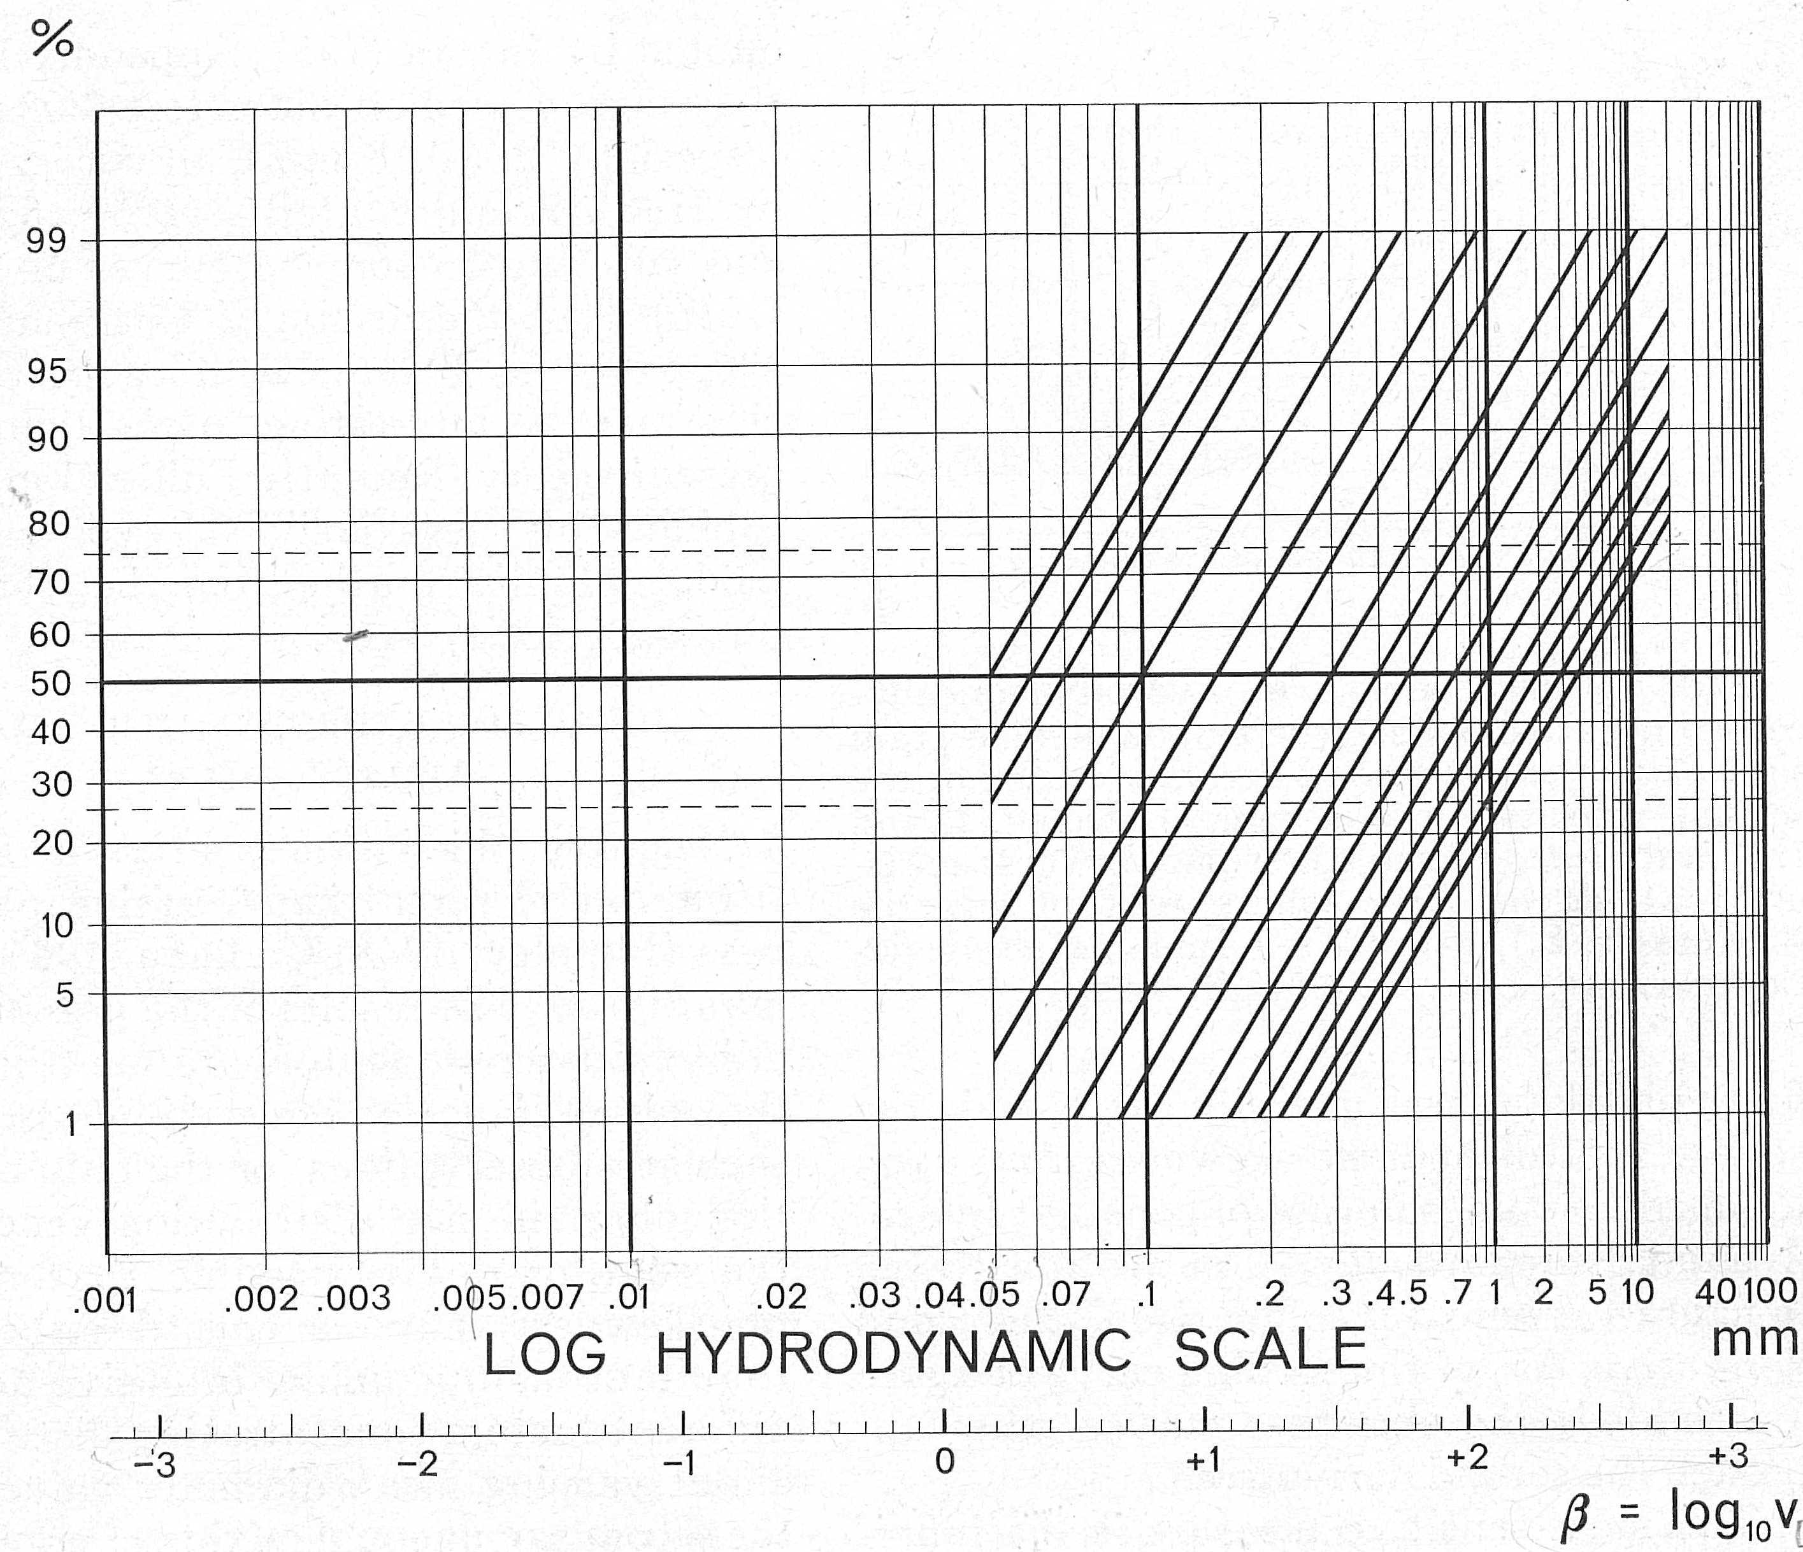
Fig. 2. ― Log hydrodynamic probability chart. Cumulative curves plotted on it as straight lines represent distributions following the eq. (2).

Fig. 3. ― Cumulative curves of figure 2 plotted on conventional log probability chart. The curves having a mean diameter of about 0.2 mm are not straight lines because their dispersion is not too small (σ_{φ} = 0.95; see fig. 4).
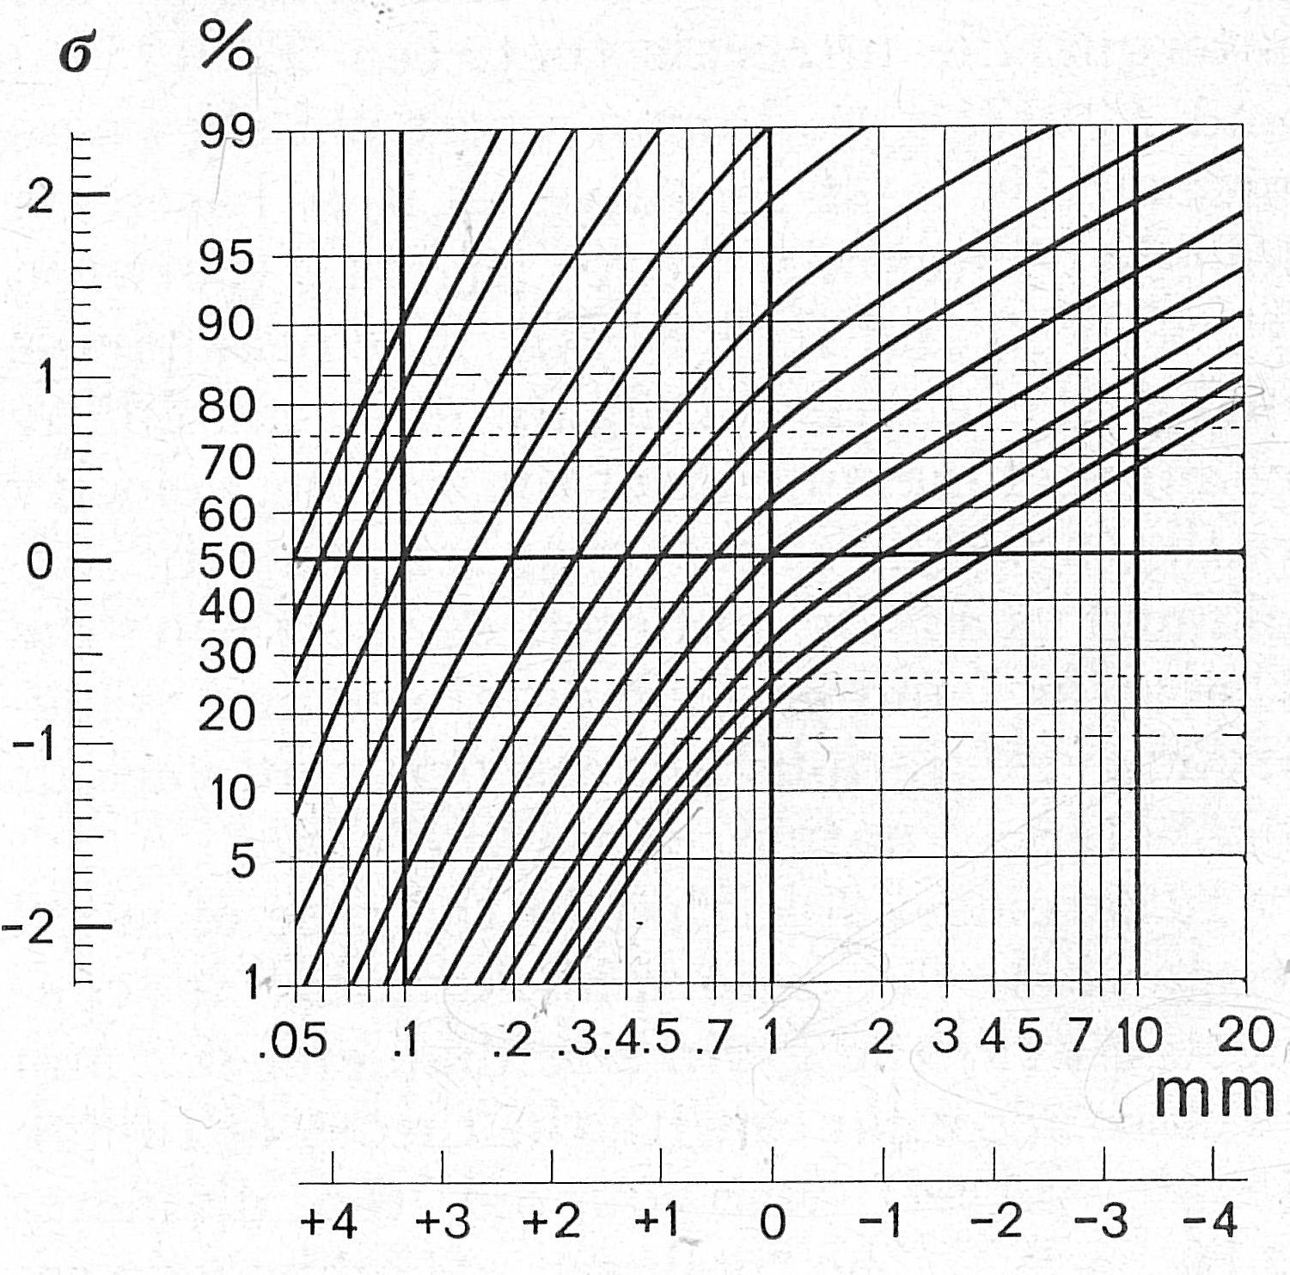

7 JIŘÍ BŘEZINA

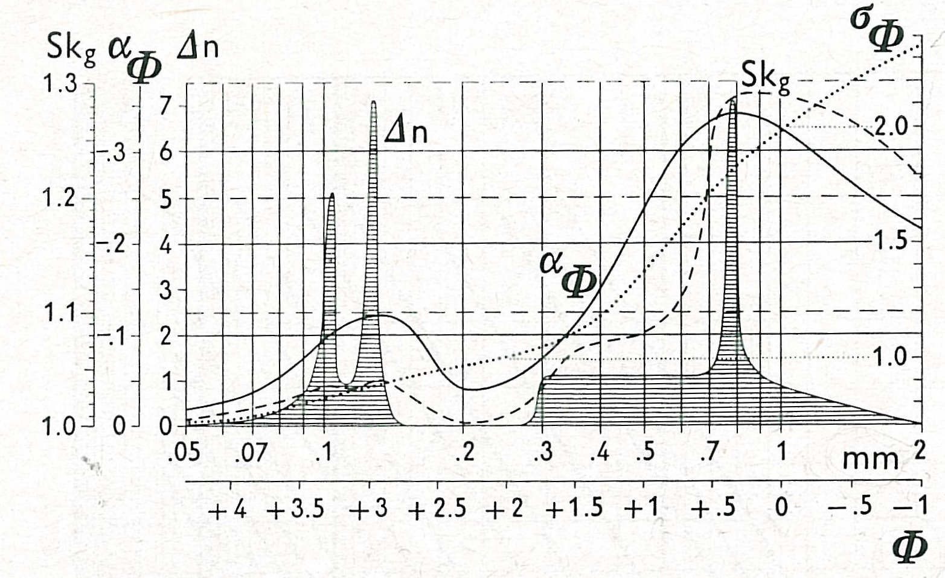
Fig. 4. ― Dependence of hydrodynamically-caused negative phi-skewness upon median grain size. Shaded curve: second derivative (Δn) of the settling velocity curve of figure 1 (see eq. la and lb); heavy line: Inman's first phi-skewness meas
ure (α_{φ}) dashed line: square root of quartile skewness (Sk_{g}); dotted line: Inman's phi-devia
tion measure, σ_{φ} (scale on right side).
first phi-skewness measure, α_{φ} and the square root of quartile skewness, Sk_{g}, upon the median values in case of constant hydro-dynamic standard deviation are illustrated in figure 4, where, for comparison, the second derivative, Δn, of the settling curve of figure 1 is added: the skewness curves must approach the second derivative.
The most sensitive measure is the infinitesimal increment of exponent values, Δn: it is based on the abscissa interval approaching zero. Consequently, the shaded curve of figure 4 has the most frequent and sharpest peaks. A less sensitive measure is the square root of quartile skewness: it is based on the interquartile intervals (between F_{φ}⁻¹(25%) and F_{φ}⁻¹(75%)). Inman’s first phi-skewness measure is least sensitive as it is based on longest intervals, two sigma (between F _{φ}⁻¹(16%) and F _{φ}⁻¹(84%)). The peakedness of all the curves of figure 4 is caused by changes of increments of the settling velocity path (fig. 1). These changes may be explained also by differences between the theoretical and experimental settling velocity curves: various shapes occur at various diameters of natural grains.
It is remarkable that in the case of small dispersion the zero phi-skewness is connected with the grain size diameter 0.2 mm in close accordance with the theory of Inman (1949, p. 64) who quoted the diameter 0.18 mm. The values of phi-skewness roughly correspond for example to those

quoted by Inman (1957; Appendix I-IV) in the range of median diameters 0.08-0.3 mm (especially 0.1-0.18 mm), to curves quoted by Hubbell and Matejka (1959; fig. 5, 14, and 20), and to some R-curves of Doeglas (1946). Also the results of Friedman (1961; 1962) on the genetic significance of skewness may be interesting in the light of the present theory. Recently Fuller (1961, 1962) explains his negatively skewed and poly-modal phi-distribution by the change of settling velocity laws.
ideal log hydrodynamic probability chart
Negative phi-skewness in grain size distributions is rarer than positive phi-skewness (Plumley, 1948; Cadigan, 1961, Friedman, 1962). The results of the present study of hydrodynamic factors are far from being the only explanation of certain negative phi-skewness observations, or the only explanation of grain size distribution genesis. On the contrary ― it is possible that negative phi-skewness may be caused either by a simultaneous but unlike intensive action of different factors concentrating distributions about varying mean diameter values or by the secondary unequal mixing of populations having different mean diameters.
The settling velocity has been calculated for isolated and nearly spherical quartz grains only. Other important influences correlatable with certain grain sizes (shape, density, collective settling leading to coagulation, content of pelitic material increasing the density and viscosity of medium, and the like) were not studied, so were not the modifications of distributions, e.g., by mixing, filtering, censoring, truncation (Tanner, 1963).
If one succeeded in expressing the influences of these factors upon the log hydro-dynamic scale correctly, an ideal log hydro-dynamic probability chart would perfectly eliminate the irregularities of grain size distribution common to all water sediments. Thus, it would be possible to study just the local grain size distribution properties reflecting provenance or peculiar hydrodynamics respectively.
Considering the decrease in settling velocity of coarse particles due to the presence of finer ones in suspension, and considering the

TRANSFORMATION OF GRAIN SIZE DISTRIBUTION 9

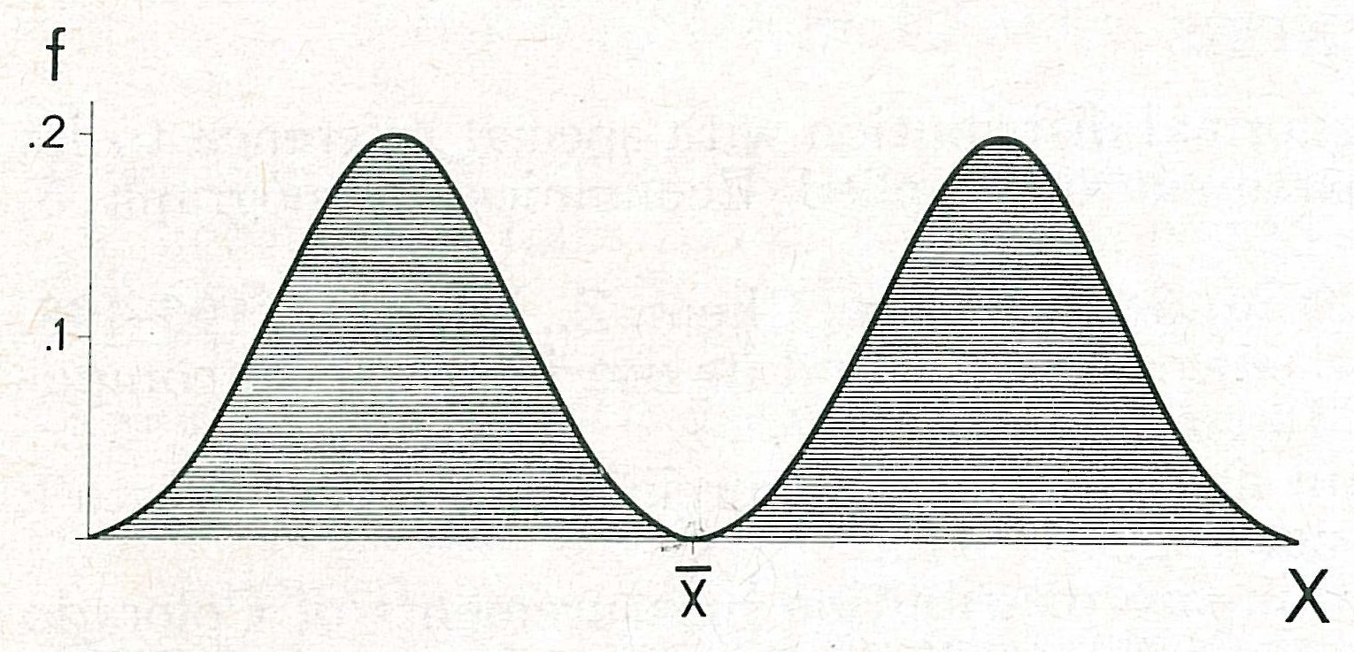
Fig. 5. ― Arithmetic mean (and median) has no genetic significance for polymodal distributions. In case of bimodal distribution with equal modes, arithmetic mean x ( = median) approaches a zero frequency value.
increase in settling velocity of fine particles due to their coagulation and entrapment of coarse ones, the ideal log hydrodynamic scale would be denser even for the sizes below 0.01 mm. Consequently, at about that size a positive phi-skewness would arise and, in the presence of greater dispersion toward coarser sizes than 0.01 mm, a leptokurtosis would appear. Such a chart would also imply a best sorting about 0.18 mm (Inman, 1949), which the present chart does not do.
The present procedure is quite deductive ― it starts from theoretically assumed conditions which may not exist in nature. Therefore, a converse procedure would be reasonable ― the inductive one, starting from the empirically observed features of grain size distributions of certain water sediments. A desirable objective would be to synthesize the four statistical parameters into an ideal log hydrodynamic scale. This objective meets with a serious obstacle: definitions of existing statistical measures are far from being general; that is, they do not characterize general distributions properly.
disadvantages of existing grain size distribution measures
The first two grain size distribution parameters in use are sufficient for lognormal distributions at most; but measures of skew-ness and kurtosis, which are functions of the deviations from lognormality, are not reliable (McCammon, 1962); polymodal distributions lie entirely beyond the power of the parameters used. Any mean value certainly cannot be so hypothetical that, for example in bimodal sediments, it may
designate a value which may not exist in them at all (fig. 5)!
The quantile measures introduced by Inman (1952) and further developed by Folk and Ward (1957) represent in central tendency the gradual transition from the median to the geometric mean if millimeters are used, and to the arithmetic mean if phi scale is used:
$$M_{φ}=\frac{F_{φ^{−1}}((\text{16}\text{\%})+F_{φ^{−1}}(\text{84}\text{\%})}{2},$$
$M_{z}=\frac{F_{φ^{−1}}(\text{16}\text{\%})+F_{φ^{−1}}(\text{50}\text{\%})+F_{φ^{−1}}(\text{84}\text{\%})}{3}$and so on, generally:
$$\begin{aligned}{\overline{x}}_{φ}=\frac{1}{n}\sum_{i=1}^{n}{F_{φ^{−1}}(t_{1})+}F_{φ^{−1}}(t_{2})+\text{.}\text{.}\text{.} \\ +F_{φ^{−1}}(t_{i})+\text{.}\text{.}\text{.}+F_{φ^{−1}}(t_{n})\end{aligned}$$

where F_{φ}⁻¹(t_{i}) = phi-quantiles of individual cumulative frequencies t_{i}; the distribution function of the frequencies t_{i} has to form an arithmetic progression with a zero mean.
Such quantile measures generally approach the moment ones which are suitable for normal or normalized distributions only. It is necessary to define grain size distribution measures which would approach the function characteristics used in mathematical analysis: maxima and minima of the first few frequency curve derivatives (Březina, 1963).
acknowledgments
For much helpful discussion and suggestions which resulted in important improvements I am indebted to R. A. Cadigan (U. S. Geological Survey, Denver), R. L. Folk (University of Texas, Austin), G. M. Friedman (Pan American Petroleum Corp., Tulsa), J. C. Griffiths (Pennsylvania State University, University Park), J. P. Harding (British Museum, London), Z. V. Jizba and W. J. Plumley (California Research Corporation, La Habra), H. Kagami (University of Tokyo), J. J. W. Rogers (Rice University, Houston), W. F. Tanner (Florida State University, Tallahassee), and J. M. Zeigler (Woods Hole Oceanographic Institution, Massachusetts).

11 JIŘÍ BŘEZINA
REFERENCES
AITCHISON, J., and Brown, J. A. C, 1957, The lognormal distribution with special reference to its uses in economics: Univ. of Cambridge, Department of Applied Economics, Monograph 5,
176 p.
Atterberg, A., 1905, Die rationelle Klassifikation der Sande und Kiese: Chem. Z., Bd. 29, p. 195-198.
Baturin, V. P., 1943, New granulometric scale for clastic sediments and its use in graphical computations (in Russian): Reports Ac. Sci. USSR, Moscow, v. 38, no. 7.
Březina, J., 1963, Classification and measures of grain size distribution, a preliminary report: Věstník Ústředního ústavu geologického, Prague, v. 38, no. 6, p. 409-413.
Cadigan, R. A., 1961, Geologic interpretation of grain-size distribution measurements of Colorado Plateau sedimentary rocks: Jour. Geology, v. 69, no. 2, p. 121-144.
Doeglas, D. J., 1946, Interpretation of the results of mechanical analysis: Jour. Sedimentary Petrology, v. 16, no. 1, p. 19-40.
Epstein, B., 1947, The mathematical description of certain breakage mechanism leading to the logarithmico-normal distribution: Jour. Franklin Institute, v. 244, no. 6, p. 471-477.
Filipoff, A. F., 1961, About size distribution of grains resulting from breakage (in Russian, with English résumé): Probability Theory and its Applications, Moscow, v. 6, no. 3, p. 299-318.
Folk, R. L., 1961, Petrology of sedimentary rocks: Hemphill's, Austin, p. 154.
Folk, R. L., and Ward, W. C., 1957, Brazos River bar: a study in the significance of grain size parameters: Jour. Sedimentary Petrology, v. 27, no. 1, p. 3-26.
Friedman, G. M., 1961, Distinction between dune, beach, and river sands from their textural characteristics: Jour. Sedimentary Petrology, v. 31, no. 4, p. 514-529.
―――, 1962, On sorting, sorting coefficients, and the lognormality of the grain-size distribution of
sandstones: Jour. Geology, v. 70, no. 6, p. 737-753.
Fuller, A. O., 1961, Size distribution characteristics of shallow marine sands from the Cape of Good Hope, South Africa: Jour. Sedimentary Petrology, v. 31, no. 2, p. 256-261.
―――, 1962, Systematic fractionation of sand in the shallow marine and beach environment off the South Africa coast: Jour. Sedimentary Petrology, v. 32, no. 3, p. 602-606.
Gebelein, H., 1956, Beiträge zum Problem der Kornverteilungen: Chemie Ingenieur Technik, bd. 28, p. 773-782.
Hatch, T., and Choate, S. P., 1929, Statistical description of the size properties of nonuniform particulate substances: Jour. Franklin Institute, v. 207, no. 3, p. 369-387.
Hopkins, C. G., 1899, A plea for a scientific basis for the division of soil particles in mechanical analysis: U. S. Dept. Agric., Dept. Chem., Bull., v. 56, p. 64-66 (not seen).
Hubbel, D. W., and Matejka, D. Q., 1959, Investigations of sediment transportation Middle Loup River at Dunning, Nebraska, with application of data from turbulence flume: U. S. Geol. Survey, Water-supply paper 1476, 123 p.
Inman, D. L., 1949, Sorting of sediments in the light of fluid mechanics: Jour. Sedimentary Petrology, v. 19, no. 2, p. 51-70.
―――, 1952, Measures for describing the size distribution of sediments: Jour. Sedimentarv Petrology, v. 22, no. 3, p. 125-145.
―――, 1957, Wave-generated ripples in nearshore sands: Beach Erosion Board, Corps of Engineers, Tech. Memo. no. 100, 42+23 p.
Kapteyn, J. C, 1903, Skew frequency curves. First paper: P. N. Noordhoff, Groningen; E. Steiger Co., New York.
―――, 1916, Skew frequency curves in biologv and statistics: Recueil des trav. bot. Néerl., v. 13, livr. 2, p. 105-157.
Kapteyn, J. C, and van Uven, M. J., 1916, Skew frequency curves in biology and statistics. Second paper: Hoitsema Brothers, Groningen, 69 p.
Kolmogoroff, A. N., 1941, Über das logarithmisch normale Verteilungsgesetz der Dimensionen der Teilchen bei Zerstückelung (in Russian and German): Reports Ac. Sci. USSR, v. 31, no. 2, p. 99-101.
Kottler, F., 1950, The distribution of particle sizes: Jour. Franklin Institute, v. 250, pt. 1, p. 339-356; pt. 2, p. 419-441.
Krumbein, W. C., 1934, Size frequency distribution of sediments: Jour. Sedimentarv Petrologv, v. 4, no. 2, p. 65-77.
―――, 1937, Korngrösseneinteilungen und statistische Analyse: Neues Jb. Min., Geol., Pal., Beil. Bd. ( = Abh.), A/Min. Petr., v. 73, p. 137-150.
McCammon, R. B., 1962, Moment measures and the shape of size frequencv distributions: Jour. Geology, v. 70, no. 1, p. 89-92.
Pearson, K., 1905, Das Fehlergesetz und seine Verallgemeinerungen durch Fechner und Pearson. A rejoinder: Biometrika, v. 4, p. 169.
―――, 1906, Skew frequency curves. A rejoinder to Professor Kapteyn: Biometrika, v. 5, p. 168.
Plumley, W. J., 1948, Black Hills terrace gravels: a study in sediment transport: Jour. Geology, v. 56, no. 6, p. 526-577.
Rittinger, P., 1863, Siebscala und Siebgruppen: Bericht über die 3. allgemeine Versammlung von Berg- u. Hüttenmännern zu Mähr.-Ostrau. (14. bis 18. Sept.), Wien, Zamarski & Dittmarsch, p. 66-68.
TRANSFORMATION OF GRAIN SIZE DISTRIBUTION 13
Robinson, G. W., 1924, The form of mechanical composition curves of soils, clays, and other granular substances: Jour. Agric. Sci., v. 14, p. 626-633.
Sarkisian, A. A., 1958, Settling of loads in turbulent flow (in Russian): Collected Papers “Open Channel Processes," USSR Ac. Sci., Moscow, p. 338-351.
Sparre, J., 1858, Beiträgen zur Aufbereitungskunde: Der Bergwerksfreund, Eisleben, p. 376, 388, 392, 677 (not seen).
―――, 1869, Zur Theorie der Separation oder Kritische Bemerkungen zu v. Rittingers Lehrbuch der Aufbereitungskunde: Oberhausen, 48 p.
Stange, K., 1953, Uber die Gesetze der Kornverteilungen bei Zerkleinerungsvorgängen: Ingenieur Archiv, Bd. 21, p. 368-380.
Tanner, W. F., 1963, Modification of sediment size distributions: manuscript, 20 p.
Tshernyj, L. M., 1950, Application of logarithmico-normal distribution law to the computation of granulometric characteristics of comminuted materials (in Russian): Reports Ac. Sci. USSR, New Ser., v. 72, no. 5, p. 929-932.
Udden, J. A., 1898, The mechanical composition of wind deposits: Augustana Library Publication I, p. 36 (not seen).
Weinig, A. J., 1933, A functional size-analysis of ore grinds: Colo. School of Mines, Quarterly, v. 28, no. 3.

